GX Zeus Advanced Script
v1.03

(by Geloxo)
www.ust101.com

Introduction

Currently one of the limitations of Arma3 curator module (aka Zeus) is a proper exportation system to allow further editing and usage on other missions. Therefore I have created a simple script set to bypass this situation and also enhance the Zeus experience by allowing multi-editing tasks shared between several Zeus players in real time, online or offline.

This addon is configured for Arma 3 by default but can be also used with other addons such as All in Arma, Unsung, Iron Front or any Arma3 and Arma2 based addons.

There are similar addons available which allow real time edition and exporting but the main advantage of this one is that it is compatible with any mission, as it does not require to have the script running on them due to the usage of native sqf format exporting instead of a propietary one.

Credits

- Functions from CBA and BIS
- Functions from Jayarma2lib
- Autohotkey freeware utility

BIS Content licenses: http://www.bistudio.com/licenses

Requirements

This addon requires CBA and BIS functions to work.
Optionally jayarma2lib can be used for improved MP exporting (not required).
Optionally the freeware Autohotkey tool can be used to autopaste clipboard contents to files (not required).

Changelog

v1.03:
- included into GX Addons mod pack. Addon version created.

v1.02:
- script initialization optimized
- added usage of setposworld to export data at the exact items placement
- added missing _sleeptime variable to generated exported script
- added class thing to the exported objects list
- explanatory note added to manual editing modes section
- debug feature extended to include more info to log files
- animals classes removed from allowed units list (they are not needed)

v1.01:

- faster script initialization
- added load feature (imported script content becomes editable again)
- added undo feature (delete last imported data)
- added private and cooperative editing modes (see only your placed units)
- added check exportable units (visual 3D marker)
- changed import feature (can be also imported from player computer to MP running session)
- changed export selected option from single object to multiple objects
- fixed teleport script
- fixed MP export and some export format errors
- debug mode added and unnecessary configuration variables removed
- configuration variables available for side vs side gameplays
- added preconfiguration of unit classes or WWII and NAM modpacks
- added unit behaviour, formation, etc to exported soldier parameters
- reduced size of exported text (default variable values ignored) and version check included

v1.0 initial release

Main features in current version

- Advanced real time edition in SP and MP (including JIP), supporting native sqf language
- Zeus players can access the content created or imported by other Zeus players in real time in MP
- Real time data exporting to clipboard, game RTP log file (or jayarma2lib log file) in SP and MP (notice clipboard is disabled by BIS in MP). Use jayarma2lib mod for better performance
- Real time data importing from multiple pre-saved scripts sources in SP and MP from player or server
- Imported data can be loaded into Zeus variables to convert it into editable again
- Configuration of available items for Zeus editors and editing options for side vs side missions
- Standard, advanced, private and cooperative editing modes
- Visual 3D markers to check which items are included in your exportable content
- Example mission included
- Most common elements edited by Zeus can be exported, but anything accessible via script commands can be added to the list in the future. Currently the following is exported:

a) Units (including their squad members)
b) Vehicles (including their crews)
c) Static weapons (including their gunner)
d) Buildings and other static objects
e) Any unit/object/vehicle position, direction, vectorup, damage and fuel
f) Soldiers UnitPos (eg: prone) and behaviour (formation, combat mode, etc)

Waypoints are not saved, but this is not due to any limitation of the script. As the real time exporting process catches the current status of everything at the moment of exporting the units may be moving around instead of staying where you initially wanted. The former idea of this script was to help editors and Zeus during multiplayer cooperative game, and to decorate and pre-define main elements such as bases, enemy forces locations, ambient life, etc. During gameplay you can always take control of those units via Zeus interface again and define their movements then, so it is almost useless to include much more information than that.

Important note: due to limitations on the writing to game´s RTP file and disabled copy to clipboard feature, exporting of large data in MP to Arma3 RTP log file is not recommended. Notice that exported data may be incomplete in that case, so please don´t blame me for this. My recommendation is that you edit in SP and import your resulting work to MP when needed or to use Jayarma2lib addon to activate its log files exporting method for MP instead, which is much more reliable and clean. GX Zeus will use it automatically when Jayarma2lib addon is loaded.

Setting and configuring the script
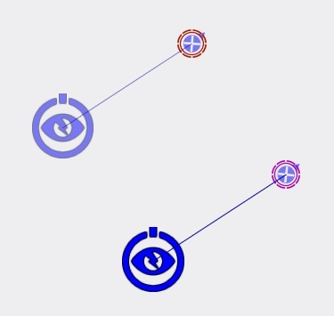
This process is very simple. Follow these steps:

- Place curtator modules (game master) in the editor
- Place the players and give them a name
- Syncronize each player with its curator module
- Write the following data at each curator module init field:

this call gx_zeus_init

You can place as many Zeus players as you want provided that each has a diferent name and all have their own curator module running the script on it. Also other curator modules can be used without the scripts running on them, but they won´t have access to this script features therefore.
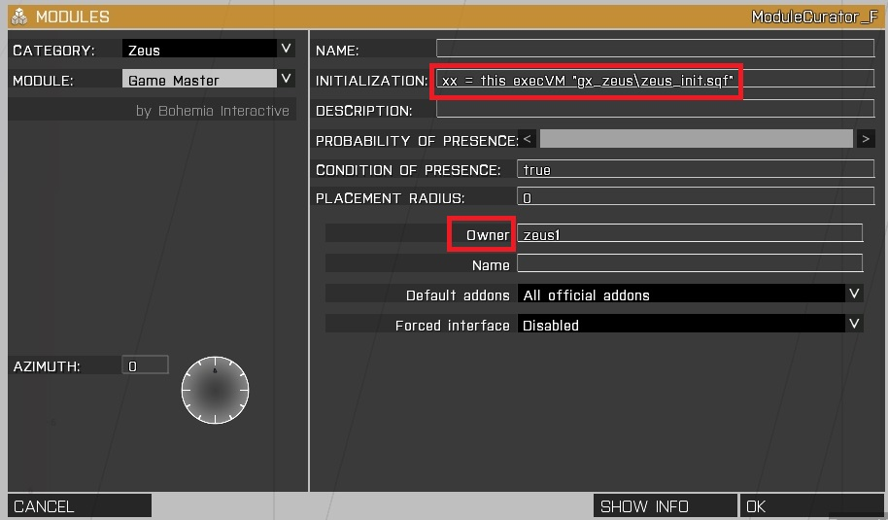

Editing with GX Zeus

The process is exactly the same as with official module (no modification done to it). When mission is launched wait for GX Zeus initialization chat messages. After that Zeus players will have the following menu available on the mouse wheel menu (Zeus options can be shown or hidden by selecting the show/hide action), depending on the configuration that was set for the mission (see next sections):

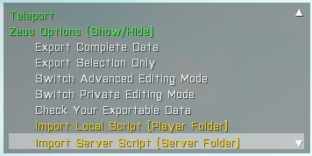
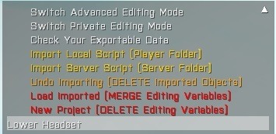
Access to Zeus interface is done as usual in game. Options are only available when Zeus interface is not active.

The options included are the following, and are unique to each player (no side effect to rest of editors):

- Teleport
A basic “click on map” teleport action to allow fast moving on map for editors

- Export complete data
Allows you to export the content of your complete edition process

- Export selection only
Just exports the curent selected object or group of objects (selection which was active before Zeus interface was closed)

- Switch advanced editing mode
Allows you to change from standard mode (default one used for playing missions or basic editing) to advanced one (where you have access to all mission items).

- Switch private editing mode
Switch to private or cooperative editing modes, allowing you to see only your own created units or all units created by the editors. This mode is not needed if the advanced one is active.

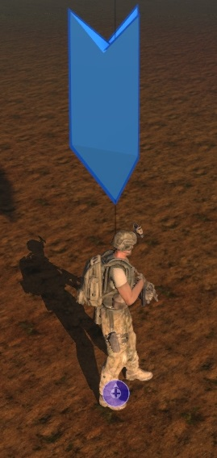
- Check your exportable data
This will temporarily show a 3D marker icon on top of all your current exportable units, so that you have a quick idea about what your data pack contains before exporting. To hide the markers before the timer elapses click on the action again. The markers are only visible for you.

- Import local script
Reads the script placed at player local import folder to import it to the SP or MP session. Any native sqf script can be used here, but to avoid errors only the ones generated by GX Zeus are recommended. You can import as many times as you want from player local folder. This feature can be deactivated in MP as it could be used for cheating from Zeus during gameplay (see variables configuration section)

- Import server script
Reads the script placed at server import folder to import it into current MP session. GX Zeus compatible script is also recommended here, but anyone can be used instead. Once mission is launched you can only import one MP script, as file will become read-only by Arma3 server. To place a new one the mission must be stopped (no server restart is needed). This feature can be deactivated in MP as it could be used for cheating from Zeus during gameplay (see variables configuration section)

- Undo importing
This will delete the last imported objects from any of the GX Zeus compatible scripts.

- Load imported
After having imported a GX Zeus compatible script (locally or at server) those units can be converted to editable format and be used for exporting again. This will merge the imported objects with your current edited ones and the imported script content will be included on your own workspace. Only GX Zeus scripts can be used here. Scripts created with v1.0 of GX Zeus are not supporting this new feature (manual tweaking would be needed). This feature is local in MP as it may override the work of other editors but the variables will be available for any Zeus who wants to load them into its workspace. Make sure to export before loading to avoid lossing your work.

- Delete exporting data
Clears the player ´s current local editing variables data to allow the creation of a new editing session. No objects will be removed, only the editing variables. Make sure to export before deleting to avoid lossing your work.

Understanding the editing process

GX Zeus stores the modifications done via editing process in local internal variables and publish them to the server, who generates the exported data in native and GX Zeus ready sqf format.

Every time you place or edit an object with Zeus it´s stored on your GX Zeus local editing variables to mark it as a change in the current mission. Then any of those new edited objects will be included in your list of items to be exported automatically by the script, but removed or non existing ones won´t.

Any unit exisiting in the original mission (created with default 2D editor or via any Arma3 script) can be also edited, and will automatically be included in your variables and become exportable, so it will then generate a clone of the former unit which was already exisiting on the map once you import again the GX Zeus script containing the cloned unit. To avoid that you have to remove the original unit from the mission and use the one on the script only.

The exporting method generates a sqf script text content to both Clipboard, Arma3 RTP log file and jayarma2lib log file (only if that addon is available), including all info about your changes (your internal editing variables). The exporting method can be used to the following purposes, among others:

- Load your work in a mission afterwards (e.g: calling the generated script at the init.sqf in mission) and use it in any SP or MP game, as you won´t require to have the GX Zeus script on that game due to the use of native sqf formats.

- Save your work for further editing with GX Zeus, even after game was closed, computer shut down, etc, and import it again later on to continue your edition process. You can then make any other modification, create a new exporting script with the content of that new work and then execute any of those scripts on the final mission (just rename them to what you want and execute them in the mission when needed, and in the desired order for the gameplay).

Important note: Do NOT merge the content of several scripts into a single one as the data may become overriden. Anything which was already existing due to previous edition sessions and which is edited again later on, will be also exported again. Use the export selection feature to generate the data only for particular elements that you changed and remove the original ones in the 2D editor if they become duplicated with the ones on the scripts (that´s easier ).

- Import your final work to a MP game session (allowing you to prepare complex missions in advance and offline) as many times as needed form editors local data scripts or from server directly. The GX Zeus exported scripts can be loaded on any running server which supports the GX Zeus by the Zeus players at any time and as many times you want (just place new scripts on the import folder), but will be 100% compatible too with any Arma3 server which is not even running GX Zeus, as they are coded in native sqf format.

- Data ready to be imported must be placed at the Userconfig folder by default, both on player´s computer during SP edition/gameplay or at server for MP edition/gameplay. See variables configuration section to define your own paths and script names for players and server side. The script name must be unchanged, and the full path will be then:

<Arma 3 path / Arma3 server path> \Userconfig\gx_zeus\gx_zeus_script.sqf

- Share your scripts with other editors, which could import them at their computers, and create a mission by “cooperative edition” among several Zeus players, even in MP and in real time during a running mission.

Particular case of soldiers and groups exporting process

This involves groups and assigned vehicles, so understanding it properly is very important and is the hardest part of the way to achieve re-usable + realtime edition. It may look as a complex approach, but take into account that you are interacting with two entities: the already exiting soldiers and the ones you include via Zeus in a running mission, and your target is to replicate the current state of the mission in the exported script everytime the mission restarts in the future and get always a consistent result. That´s why I decided to take the safest possible approach, which involves working with squad leaders directly, as they are unique and contain all the needed references to spawn the rest of other soldiers in the group.

Remember the target of this tool: ease the editing process, not turning you mad with an even more complex process than the standard 2D editing. So please, use it in the easiest way too.

It works internally as follows:

- Script detects any group leaders edited by you and marks them as edited (an therefore exportable)
- Only the squadmates which were also edited by you inside that squad will be marked as exportable too. So, if you mix groups of units placed by you with existing units on the map coming from the original mission for instance, make sure you edit (easiest way is to move them a little) any soldier existing in the mission that you want to convert it in exportable in the resulting group as well. But take into account that then you will have a clone of the unit once you run the exported script, so you should remove the old one in the 2D editor to have a consistent result.
- Units edited by Zeus can be mounted in vehicles, as script will check if the unit is assigned to any vehicle which exists also in the list of edited (and therefore exportable) vehicles, and link them in the final exported script. In you order them to mount on any existing vehicle without editing that vehicle the units will be still created but will not be assigned to any vehicle.
- If you edit an existing vehicle already containing a crew which was not edited by you, the vehicle and its complete crew will be converted automatically to a edited and exportable group. Doing so we prevent to replicate the crews assignment process, which was already done at the leader exporting step.
- If you group your edited objects with existing group leaders which are not edited by you (e.g: units already present on the mission) your edited unit will be removed from the exportable list. This avoids the creation of undesired cloning chains on multiple units.
- Don´t export when you are remotely controlling units. This will be understood by the Arma3 game as your character being part of the group of edited soldiers. Just leave the remote control state and go back to your Zeus unit.
- If you group one of your edited soldiers to an existing group leader placed on the 2D editor, and don´t edit that group leader, your formerly edited soldier will NOT be exported.

Best working method (error and “headache” free)

Try to avoid mixing things, keep mission and Zeus created items separately and use the advanced mode only when really needing it, as in the standard mode you will only have access to your own content, content from other editors or imported content from scripts, which is more than enough.

Just create vehicles with Zeus (emtpy or not ones), create groups of soldiers and then order the desired team members to mount the desired vehicles. You can take remote control of them via Zeus to place them at specific turret positions, as that info is also saved for the exportation, and leave the remote control state to continue editing.

Everything will be exported fine, inside and outside the proper vehicles, and no undesired cloning will happen when calling the script in the mission.

In case of doubts about what the export will contain you can always try to export a selection of units instead of the complete mission and see what the script contains to understand what you will have on the complete mission exporting process.

Save clipboard to userconfig file automatically (optional)

Every time you export and content is copied to clipboard, which is the fastest method to gather information, you need to take care of the data and paste it to a file to save your work. In order to help you with this process I have included a small Autohotkey script that can be run in parallel to Arma 3 and will automatically save your copied content to the gx_script.sqf file at Userconfig, so you won´t need to minimize game to do it. This is completely optional and you can use any other existing utility to achieve the same result.

To activate it simply double click on the .ahk file and forget about it (a icon in the tray bar will appear).

Once launched the script will only be active when the game is running and your Arma 3 window is on the foremost. But take into account that any copy action during game (eg: to place text on the init fields) will be then also written to your script and overwrite it. Use it only when you are editing and save your script to a diferent place after the exporting is done and you are happy with the result.

You will need to install Autohotkey (freeware tool) for this to work. Ensure you open the file with a text editor to change the default Userconfig file path to yours on the last lines of it (my default path is used):

F:\SteamLibrary\SteamApps\common\Arma 3\Userconfig\gx_zeus\gx_zeus_script.sqf

Editing modes

The standard mode is the default working mode as does not make any difference with Vanilla curator module behaviour, except the following improvements:

- Units available for the Zeus player edition can be defined, for instance to ease the edition with Vietnam or WWII mods, by selecting which units to display and hiding the default A3 content. This also allows you to hide non compatible units or non desired content and simplify the lists. See next sections to learn how to configure the script variables.
- Human playable units are visible to Zeus in MP missions.
- Content created by other Zeus players is accesible in real time (cooperative editing mode).
- Content imported from scripts can be edited by loading it into player workspace.

The advanced mode gives the same features but in addition grants you access to almost everthing that is available in the mission (newly added content is refreshed periodically), such as:

- Objects formerly placed in the standard 2D editor
- Content which is spawned by external scripts or imported via GX Zeus ones

In case cooperative editing is disabled (see variables configuration section) then advanced mode won´t be available, as enemy Zeus players could have access to your units too (side vs side gameplays).

Although it´s possible to, the usage of this mode during gameplay is not the best option you should choose, as you will be saturated with information and icons such as all AI waypoints, objects and things that you don´t really need for a standard MP mission. Use it to fine tune or add items and switch back to the standard one for easier usage during gameplay.

The private and cooperative modes allow you to filter which content you have access to during operation in standard mode editing (they are ignored in advanced mode), either only your created content or the content created by all editors too.

NOTE: During cooperative editing the recently placed units by other editors may not become accesible to you until the script refresh loop has run (typically 10s). You may also need to switch from standard to expert modes or from private to coop modes to have access to them as your variables will be refreshed with those actions. If you still experience problems accessing other editors units please close Zeus interface and reopen it again and ensure all players initialization was properly done (chat messages appear when a editor script initialization was finished).

Script customization and variables definition

The following variables can be used to customize your game experience in Zeus:

gx_curator_cooperative = true;

Set it to false to disable cooperative editing (make each Zeus player created units not vissible for other Zeus players). Use false in side vs side Zeus missions so that enemy side Zeus units does not have access to friendly ones. This will also disable the advanced mode editing feature.

gx_curator_showplayers = true;

Set it to false if you don´t want Zeus to see the human players. Use false in case of side vs side missions.

gx_curator_teleport = true;

Set it to false to disable teleport feature on Zeus players.

gx_curator_allowimport = true;

Set it to false to disable the import from scripts feature in MP gameplays (as it could be used for cheating from Zeus players)

gx_curator_importpath = "\userconfig\gx_zeus\gx_zeus_script.sqf";
gx_curator_serverimportpath = "\userconfig\gx_zeus\gx_zeus_script.sqf";

This defines paths and script names of imported scripts (for local and server importing cases).

gx_curator_debug = false;

Set it to true to activate debug mode. It will copy to your clipboard the list of units which are removed during initialization. This can be used to filter the ones you want to keep when WWII or NAM mod packs are active. Independently from this setting script will automatically write general debug info to Jayarma2lib and RTP log files.

gx_curator_remove_A2 = false;

Set it to true to remove all incompatible units from Arma2 based mods, when using Arma2 based mods via All in Arma (eg: Unsung mod). Notice this will hide all Man class units, including the native A3 ones and the ones of any addon. You will need to reload the desired classes inside CfgPatches via the custom units array variables (see below)

gx_curator_remove_A3 = false;

Set it to true to remove the default A3 units when running mods based on different eras (eg: Iron Front)

Custom units addons classes are split into three arrays, which will be used automatically when a mod set is detected. Currently I´m supporting Unsung and Iron Front ones as are the most common ones:

gx_curator_allowed_A3units = [];
gx_curator_allowed_units_NAM = [];
gx_curator_allowed_units_WWII = [];

The first two ones are used to define which units classnames you want to see at Zeus menu when Unsung or Iron Front mod packs are active. Include the classnames of the CfgPatches configs which define the desired units.

The last one is used to “restore” the default Arma3 units in case of using the _remove_A2 = true variable. It also allows you to add any extra custom unit which was not loaded by Arma3 Zeus or limit the ones to see.

Use the string format to add items to any of those three arrays, for example:

gx_curator_allowed_A3units = ["A3_Characters_F_BLUFOR", "A3_Characters_F_Civil"]

